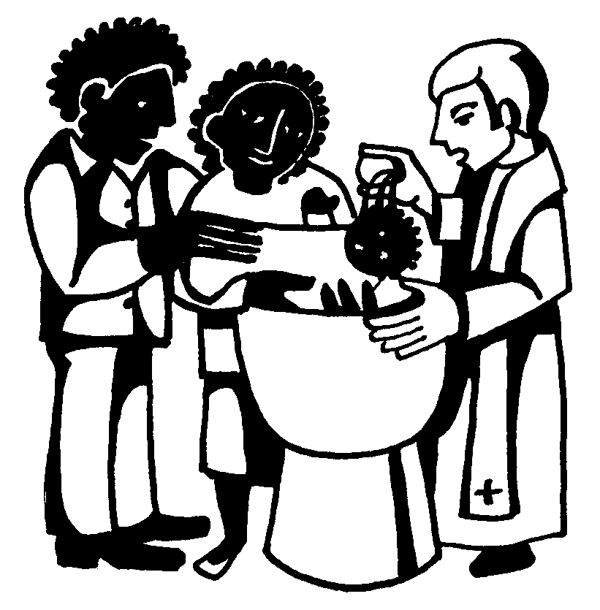
THE SACRAMENT OF HOLY BAPTISM

Book of Common Prayer, p. 298

"Baptism is full initiation by water and the Holy Spirit into Christ's Body the Church. The bond which God establishes in Baptism is indissoluble" (BCP, p. 298)

"Holy Baptism is the sacrament by which God adopts us a his children and makes us members of Christ's body, the Church, and inheritors of the kingdom of God...The inward and spiritual grace in Baptism is union with Christ in his death and resurrection, birth into God's family the Church, forgiveness of sins, and new life in the Holy Spirit" (BCP, p. 858).

1. Baptism is a sacrament of the Paschal Mystery of Jesus Christ, the mystery of Christ’s death and resurrection at Easter (pascha). The most appropriate context for it is the Eucharist on the Lord's Day. Because Baptism marks incorporation into the Body of Christ, it is most properly celebrated in the context of public worship. In the early Church, Baptism, Anointing with Oil (chrismation), and Holy Eucharist were all three administered as part of one rite by which the initiate becomes a full member of the Church. Participation in the Eucharist is the climax of the act of Baptism. For this reason, all baptized Christians (including infants and children) are welcome to receive the Eucharist.

2. The Sacrament of Holy Baptism is most appropriately celebrated on the following feast days:

1. Pentecost (May/June): Because baptism focuses on the gift of the Holy Spirit
2. All Saints (November 1): Because all Christians, both living and dead, are united into one fellowship in Jesus Christ.
3. Baptism of the Lord (January): Because Jesus' baptism forms the background of all Christian baptism.
4. Great Vigil of Easter (March/April): Because baptism is a sacrament of the Paschal Mystery (Jesus’ death and resurrection)

3. No additional rite or ceremony (such as Confirmation) is needed to complete initiation into the Church. While training and instruction in the faith are crucial, it is not mastery of knowledge that admits us to God's people but rather God's gracious act in Jesus Christ. Baptism is ecclesial in nature, that is, it has to do with the church; it is not a rite which applies simply to an individual. Therefore, private baptisms and "believer's baptism" (the idea that baptism marks one's public profession of faith) are not appropriate.

4. Presentation and Examination of Candidates (BCP, 301-303): All candidates for baptism are to be publicly presented and examined and each candidate must be sponsored by at least one baptized person (BCP, p. 298). The role of the sponsor or godparent is not simply honorary: "Sponsors of adults and older children present their candidates and thereby signify their endorsement of the candidates and their intention to support them by prayer and example in their Christian life. Sponsors of infants, commonly called godparents, present their candidates, make promises in their own names, and also take vows on behalf of their candidates" (BCP, p. 298). Parents and godparents promise that they will be responsible for their candidate being brought up in the Christian faith and that they will pray for and provide an example to their candidate (BCP, p. 302).
Each candidate is examined by being asked six questions, three dealing with renunciations and three dealing with positive actions. Adults answer questions for themselves while parents and godparents answer for infants or young children (BCP, pp. 320-303). The examination concludes with the congregation being asked to make a promise as well: "Will you who witness these vows do all in your power to support these persons in their life in Christ" (BCP, p. 303).

5. The Baptismal Covenant (BCP, pp. 304-307): The ecclesial nature of baptism can be seen in the fact that each time a person is baptized those who have already been baptized renew their baptismal vows. This is a reminder to us that baptism is never a matter of being “done.” Our baptism should be the central reality of our entire life--our life is a living out of our baptismal covenant.
The Apostles' Creed is a baptismal creed-it was the baptismal creed of the church in Rome around 150 AD. This creed is not an exhaustive statement of the Christian faith but an outline of the faith into which we are baptized. It is Trinitarian in structure, being constructed out of three paragraphs dealing with God the Father, God the Son, and God the Holy Spirit. The "holy catholic Church" is properly treated under the Holy Spirit. Creeds remind us of the givenness and objectivity of the Christian faith-the faith is neither our possession nor our invention. Christianity was created by God in Jesus Christ through the power of the Holy Spirit, and the Church is part of that creation.
Five questions follow the Creed which outline the baptized life—baptism defines the shape of the Christian life. Ultimately, the way we live should be a living out of and living into our baptism. As Christians, our lives are defined by five things: faithfulness to the Church, continual repentance, proclaiming our faith by word and deed, serving Christ in others, and respecting the fundamental dignity of other human beings. Baptism is the foundation of Christian ethics. If you want to know how to live your Christian life, read the service of Holy Baptism. Think about the promises made by the candidates. What does it mean to renounce the devil and all his works? What does it mean to keep God's holy will and commandments?
Baptism involves two natural elements or “signs”—water and oil. The water of baptism signifies cleansing: "Now sanctify this water, we pray you, by the power of your Holy Spirit, that those who are cleansed from sin and born again may continue in the risen life of Jesus Christ" (BCP, p. 307). Water also signifies death and rebirth, as is made clear in the Thanksgiving over the Water: "We thank you, Father, for the water of Baptism. In it we are buried with Christ in his death. By it we share in his resurrection. Through it, we are reborn by the Holy Spirit" (BCP, p. 306). The second natural “sign” is oil. Oil, blessed by the bishop, is used to make the sign of the cross on the candidate's forehead. Oil is used in the Old Testament to anoint prophets and kings. In baptism it has a double significance; it recalls Jesus' anointing by the Holy Spirit and it symbolizes the incorporation of the baptized person into the royal priesthood of Christ (BCP, p. 307).

6. The Baptism (BCP, pp. 307-308): The act of baptism itself involves two liturgical actions. The first action involves the water. Water is either poured over the head of the candidate or the candidate is immersed in the water. This is done "in the Name of the Father, and of the Son, and of the Holy Spirit" (BCP, p. 307). This ‘Trinitarian formula’ reflects the fact that ultimately baptism is an act of the Triune God—the ultimate celebrant of all the sacraments is Christ himself. Then the consecrated oil is applied to the candidate's forehead. This reminds us that baptism is an ordination to priesthood, an incorporation to the priesthood exercised by the Body of Christ. As noted earlier, baptism finds is fulfillment in participation in the Eucharist.
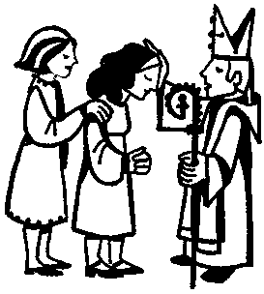
The Sacramental rite of Confirmation

Book of Common Prayer, pp. 412-419

"In the course of their Christian development, those baptized at an early age are expected, when they are ready and have been duly prepared, to make a mature public affirmation of their faith and commitment to the responsibilities of their Baptism and to receive the laying on of hands by the bishop. Those baptized as adults...are also expected to make a public affirmation of their faith and commitment to the responsibilities of their Baptism in the presence of a bishop and to receive the laying on of hands" (BCP, p. 412).

"Confirmation is the rite in which we express a mature commitment to Christ, and receive strength from the Holy Spirit through prayer and the laying on of hands by a bishop" (BCP, p. 860).

Confirmation has often been misunderstood. It is not the point at which one becomes a member of the Church. As the BCP's rubrics, or guidelines, make clear(p. 298), this takes place in Baptism. Confirmation does not add to the Sacrament of Baptism. Confirmation does not initiate a person into the Body of Christ but, rather, a strengthening or confirmation of what we have received in Baptism. Because of this, Confirmation is an integral part of the Christian vocation and not simply a "hoop" to jump through. Confirmation reminds us that the Christian life, begun in Baptism, is a journey for which we need renewed strength. It is important, therefore, to see this sacrament as ministering to our need.

Candidates for Confirmation make no new vows, rather, they are asked to reaffirm the vows that they made or were made for them at baptism. The bishop examines each candidate using two questions: (1) Do you reaffirm your renunciation of evil? (2) Do you renew your commitment to Jesus Christ?" (BCP, p415) When the candidates have been examined, every baptized member of the congregation is invited to reaffirm their baptismal vows in the Baptismal Covenant (BCP, pp. 416-417).

Like Baptism, Confirmation is a work of the Holy Spirit. The prayer which the bishop prays for all the candidates makes this clear: "Almighty God, we thank you that by the death and resurrection of your Son Jesus Christ you have overcome sin and brought us to yourself; and that by the sealing of the Holy Spirit you have bound us to your service." This makes the meaning of Baptism clear-- Baptism is a sealing with the Holy Spirit which binds us to the service of God. The prayer goes on to relate Confirmation to Baptism: "Renew in these your servants the covenant you made with them at their Baptism. Send them forth in the power of that Spirit to perform the service you set before them." (BCP, p418) In Confirmation, the bishop prays that the Holy Spirit will confirm his (the Holy Spirit's) own work begun in each person at their baptism.

It is important to point out that Confirmation is not primarily the point at which one makes a public profession of faith, this would be placing too much emphasis on the individual. Confirmation is not primarily the point at which one becomes responsible "for one's own faith" but the point at which a person receives the strengthening power of the Holy Spirit to live out their baptism. The primary emphasis of all the sacraments and sacramental rites is not on what we do but on what God does. Confirmation does, however, involve a public profession of faith in the presence of a bishop who represents the whole Church. The presence of the bishop reminds us that the faith into which we were baptized and for which we are confirmed by the Holy Spirit is not our own faith but the faith of the whole Church which both precedes and follows us.
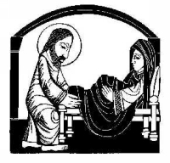
The Sacramental Rite of Unction

Book of Common Prayer, pp.453-467

“Unction is the rite of anointing the sick with oil, or the laying on of hands, by which God's grace is given for the healing of spirit, mind, and body" (BCP, p. 861).

"Are any among you sick? They should call for the elders of the church and have them pray over them, anointing them with oil in the name of the Lord" (James 5:14)

The New Testament makes it clear that Jesus exercised a ministry of healing. This ministry of healing was an essential part of his proclamation of the kingdom of God in that Jesus comes not merely to preach a message but also to enact what he proclaims. Matthew makes this point by “framing”’ the Sermon on the Mount (Matthew 5:1-7:27) with accounts of Jesus’ healing ministry. Immediately before the Sermon on the Mount we read that "Jesus went throughout Galilee, teaching in their synagogues and proclaiming the good news of the kingdom and curing every disease and every sickness among the people" (Matthew 4:23). Immediately after the Sermon on the Mount, Jesus cleanses a leper (Matthew 8: 1-4). It is abundantly clear that the authority to heal is delegated to the apostles who are also expected to exercise a healing ministry—the twelve are sent out "to proclaim the kingdom of God and to heal" (Luke 9:2). This ministry of healing is intensified by the resurrection and the gift of the Holy Spirit: "A great number of people would also gather from the towns around Jerusalem, bringing the sick and those tormented by unclean spirits, and they were all cured (Acts 5:16).

The ministry of healing, as understood in Scripture, is not primarily a humanitarian effort. Jesus did not heal people as an end in itself nor does the Church exercise the ministry of healing as an end in itself The ministry of healing is a sign--a sign which points to God's plan for all of creation. In the ministry of healing we catch a glimpse of God's promise to restore all of creation. In this sense, the ministry of healing is not to be regarded as exotic or weird but as an essential part of the Church's ministry.

The Rite of Unction is not to be seen as a substitute for medical care. or as in competition with medical care. The time to seek anointing for healing is not when one is beyond the help of physicians but in all times of special emotional, physical, or spiritual need. Unction must not be confused with magic; the oil of unction is not a miracle potion which infallibly delivers a cure upon application. Rather, unction is a sacrament of the Pascal Mystery of Jesus Christ which conveys the grace of Christ's death and resurrection and, thus, brings about healing but not necessarily a "cure". Healing is holistic in nature and pertains to each dimension of life, the physical, the spiritual, and the mental. Therefore, instead of "curing" physical ailment, this sacrament may enable a person to live with the ailment. Our images of healing have been too shaped by people throwing aside their crutches and walking and while this may indeed happen, healing can not be reduced to this.

The Rite of Unction is eschatological in nature, that is, will be realized fully upon Christ’s return. This means that its value does not simply consist in immediate results. Ultimately this sacrament is a sign of the final healing that God intends for us, a healing which comes from the Pascal Mystery of Jesus Christ: "As you are outwardly anointed with this holy oil, so may our heavenly Father grant you the inward anointing of the Holy Spirit. Of his great mercy, may he forgive you your sins, release you from suffering, and restore you to wholeness and strength. May he deliver you from all evil, preserve you in all goodness, and bring you to everlasting live through Jesus Christ our Lord" (BCP, p. 456; see also Book of Occasional Services, p. 170).
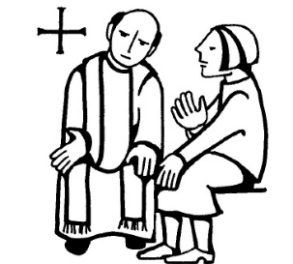
The Sacramental Rite of Reconciliation

Book of Common Prayer, pp. 446-452

"The ministry of reconciliation, which has been committed by Christ to his Church, is exercised through the care each Christian has for others, through the common prayer of Christians assembled for public worship, and through the priesthood of the Church and its ministers declaring absolution" (BCP, p. 446).

"Reconciliation of a Penitent, or Penance, is the rite in which those who repent of their sins may confess them to God in the presence of a priest, and receive the assurance of pardon and the grace of absolution" (BCP, p. 861).

"Receive the Holy Spirit. If you forgive the sins of any, they are forgiven them; if you retain the sins of any, they are retained" (John 20:22, 23).

"All this is from God, who reconciled us to himself through Christ, and has given us the ministry of reconciliation" (II Corinthians 5:18).

The sacramental Rite of Reconciliation offends our modern American sensibilities for it insists that our relationship with God, while personal, is not private.

It is clear that the ministry of Jesus was one of reconciliation. One of Jesus' most offensive claims was his claim to exercise divine authority in forgiving sins. Paul speaks of the whole of Jesus’ ministry, death, and resurrection as being about reconciliation and he clearly thinks that this ministry of reconciliation has been entrusted to the Church (II Corinthians 5:17-6:2; Ephesians 2). In his account of the Resurrection, John tells us that the risen Christ appeared to the apostles, bestowed the gift of the Holy Spirit upon them, and gave them the commission to forgive and retain sins. The New Testament makes it clear that this sacrament has to be seen in the context of the Paschal Mystery-- Jesus' death and resurrection make forgiveness of sin and reconciliation a reality and it is this reality upon which the Church's ministry of reconciliation is based.

The BCP makes it clear that the ministry of reconciliation "has been committed by Christ to his Church" and that it is exercised in a variety of ways. It is exercised by all Christians who are called to be “’agents of reconciliation”, through our work and ministry in the world, through our common prayer in the context of the Church's liturgy, and through the “priesthood of the Church and its ministers.” This means that the Rite of Reconciliation represents one dimension of the Church's ministry of reconciliation.

It needs to be noted that Reconciliation is not the only Rite which deals with forgiveness. The two great sacraments, Baptism and Eucharist, both have reconciliation at their centers. Both Baptism, as "union with Christ in his death and resurrection, forgiveness of sins, and new life in the Holy Spirit (BCP, p. 858), and Eucharist, as "the way by which the sacrifice of Christ is made present, and in which he unites us to his one offering of himself' (BCP, p. 859), are sacraments of incorporation into the Paschal Mystery of Christ, the Mystery from which we receive God's forgiveness, reconciliation, and a transformed life. Because this is true, the Sacrament of Reconciliation should not be seen in isolation, it is one of several ways through which the reconciling work of Christ is carried out in his Church.

The Anglican attitude toward Reconciliation has always been pastoral rather than juridical; the Rite is seen as addressing a human need, rather than a legal requirement or as a remedy for the breaking of a law. This sacrament is one of the means through which Christ sanctifies (sets apart or makes holy) his people. The Anglican attitude toward Reconciliation has been "All may; some should; none must". The BCP makes it clear that Reconciliation is "available for those who desire it" (p. 446)—it is for those who wish to make use of this means of grace.

The BCP provides two forms for the Reconciliation of a Penitent. Form I (BCP, pp. 447-448) comes from the Anglican tradition while Form II comes from the Eastern Church (BCP, pp. 449-452. Both have the same structure and simple in nature. The penitent offers a confession then the priest offers counsel and after this pronounces absolution. In the case of both forms the formula for absolution is significant because it makes clear that the priest offers absolution not on his or her own authority but on the authority of Christ: "Our Lord Jesus Christ, who offered himself to be sacrificed for us to the Father, and who conferred power on his Church to forgive sin, absolve you through my ministry by the grace of the Holy Spirit, and restore you in the perfect peace of the Church" (BCP, p. 448). In form II the absolution is accompanied by a liturgical action, the laying on of hands.

The physical setting of Reconciliation is important. In Anglican practice, as with contemporary Roman Catholic practice, the priest is seated with the altar rail while the penitent kneels at the rail. Or, priest and penitent may be seated facing each other (BCP, p. 446).

Two rubrics (guidelines) govern the content of confessions. First, the "content of a confession is not normally a matter of subsequent discussion" (BCP, p. 446), meaning that the content of a confession is only discussed again if the penitent asks for this. Second, the "secrecy of a confession is morally absolute for the confessor, and must under no circumstances be broken" (BCP, p. 446).

The priest may assign a penance which the penitent is to perform as an act of thanksgiving. Absolution is not conditional upon the completion of the penance and the penance in no way brings about forgiveness. Rather, a penance is performed as a way of expressing thanks for the forgiveness received. A sinner does not perform penance in order to receive forgiveness, but on account of having already received it.

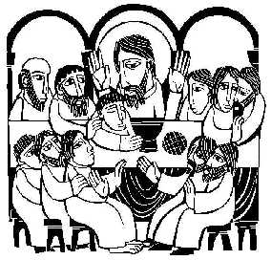
The Sacrament of the Holy Eucharist

Book of Common Prayer, pp.315-409

"The benefits we receive [from the Eucharist] are forgiveness of our sins, the strengthening of our union with Christ and one another, and the foretaste of the heavenly banquet which is our nourishment in eternal life" (BCP, pp. 860-861).

"The cup of blessing that we bless, is it not a sharing in the blood of Christ? The bread that we break, is it not a sharing in the body of Christ? Because there is one bread, we who are many are one body, for we all partake of the one bread" (I Corinthians 10:16-17)

"Very truly, I tell you, unless you eat the flesh of the Son of Man and drink his blood, you have no life in you. Those who eat my flesh and drink my blood have eternal life, and I will raise them up on the last day; for my flesh is true food and my blood is true drink" (John 6:53-5 5)

With one sentence at the beginning of the BCP, the Episcopal Church makes a very important theological statement. It identifies the Eucharist as "the principal act of Christian worship on the Lord's Day and other major Feasts" (BCP, p. 13). This means that the celebration of the Eucharist is the normative way for us to keep the Lord's Day. The BCP's clear intention is that the Eucharist will be celebrated each Lord's Day as the principal act of worship. In intending this, the Prayer Book maintains the practice of the early Church.

The Eucharist and the Paschal Mystery

The Eucharist was probably the first distinctively Christian form of worship; it was the celebration of the Eucharist that distinguished the early Christians (who were Jewish). Theologically speaking, the Eucharist has many dimensions and cannot be reduced to meaning one thing. While complex in meaning, however, the Eucharist is above and beyond all things a sacrament of the Paschal Mystery of Jesus Christ, which is to say that it derives its primary meaning from the mystery of Jesus’ death and resurrection at Easter (pascha). Within the New Testament and during the early period of Christianity, the Eucharist was never seen simply as a memorial of the Last Supper, but as the re-membering or making present (anamnesis) of Jesus’ self-offering.

All four Gospels make it clear that Jesus' death occurred near the Jewish Passover. Whether the Last Supper actually took place on the eve of Passover is finally not important. The accounts of this meal on Holy Thursday (the night Jesus was arrested) in Matthew, Mark, and Luke (John does not provide an account of the meal but assumes that it took place) all make it clear that Jesus intended the meal to be seen in the context of the Passover. Passover was, of course, the central feast of Judaism since it both celebrated liberation of Israel from slavery in Egypt (Exodus 12) and looked forward to God's final act of liberation. It is important to note that the Passover was not simply a memorial rite but anticipated a future act of God on behalf of Israel; Jews celebrating the Passover looked both backwards and forwards. Just as God created the Passover meal on the eve of Israel's deliverance from Egypt to mark a great act of liberation, so Jesus created a new Passover meal to mark God great and final act of liberation at Easter. Matthew, Mark, and Luke all make it clear that Jesus took the symbolism of the Passover (the slain lamb, the meal, the cup of wine, deliverance from bondage, and promise of entrance into the promised land) and applied it to his own death which was to occur the following day (Good Friday). This is especially clear in Luke where Jesus tells his disciples "1 have eagerly desired to eat this Passover with you before I suffer" (Luke 22:15, 16). Jesus alerts the disciples that this is not an ordinary Passover--he is changing the meaning of the Passover. Jesus reinterprets the symbols of bread and wine to refer to his approaching death. This becomes explicit at the blessing of the cup: "This cup that is poured out for you is the new covenant in my blood" (Luke 22:19; see also Matthew 26:28). In Jesus, God's great and final exodus is realized and in him God makes a new covenant (or solemn agreement) with Israel. The fact that the Passover was instituted by God lends tremendous significance to Jesus' altering it—he clearly understood himself to be acting with a divine authority. Jesus' actions at this meal were radical in that he used his approaching death to redefine the Passover. In doing this he also made the claim that the whole history of Israel culminates in him.

In the great and final Passover of the Eucharist we celebrate the great and final exodus—the exodus from sin and death. This is the interpretation with which Paul invests the Eucharist when he writes that "our paschal lamb, Christ, has been sacrificed. Therefore, let us celebrate the festival" (I Corinthians 5:7, 8). The Eucharist is the festival meal of the crucified and risen Christ and as such it constitutes the essence of the Church. The Church is not a religious institution which celebrates the Eucharist among other rites; the celebration of the Eucharist constitutes the Church.

The Eucharist as Sacrifice

Protestants typically have wanted to avoid talk about the Eucharist being a sacrifice but this does not change the fact that the Eucharist has an unavoidably sacrificial dimension. The passage just quoted from 1 Corinthians helps us to see this clearly. The Passover was the symbolic background of Jesus' last meal with his disciples and the Passover involved sacrifice. On the day before Passover, lambs were slaughtered in accordance with Exodus 12:1-13. The blood of the Passover lambs was originally applied to the lintels of the houses inhabited by Israelites so that God would "pass over" them and strike down the firstborn of the Egyptians. In this Passover, the Israelites were literally saved "by the blood of the Iamb". It is quite clear that Jesus understood himself to be the new Passover lamb and that Paul certainly saw Jesus' death in this light. Jesus' sacrificial death is so central to Paul that he can sum up the meaning of the Church's eucharistic meal by saying that "as often as you eat this bread and drink the cup, you proclaim the Lord's death until he comes" (1 Corinthians 11:26). (Note that Paul also gives the Eucharist a future orientation by mentioning Christ's return.)

The New Testament accepts the sacrificial nature of Jesus' death and his life as a given. Matthew (20:28), Mark (10:45), John (1:29) and Hebrews (9) all see Jesus' death as having been sacrificial. The New Testament culminates in a vision of Jesus as a slaughtered lamb (Revelation 5:6). Colossians (1:19-20) works out the cosmic implications of this sacrifice in that through Jesus' sacrificial death "God was pleased to reconcile to himself all things, whether on earth or in heaven, by making peace through the blood of his [Jesus'] cross."

The Eucharist does not repeat the unique, once for all (Romans 6:10) sacrifice of Christ; it can not do this because this sacrifice cannot be repeated. The Eucharist does, however, make Christ's sacrifice present to his people; through the Eucharist we come to share in the fruit of Christ's atoning death and life giving resurrection. In response, we offer a “sacrifice” of thankfulness and self-dedication. This is made most clear in Holy Eucharist Rite I: "And we earnestly desire thy fatherly goodness mercifully to accept this our sacrifice of praise and thanksgiving; most humbly beseeching thee to grant that, by the merits and death of thy Son Jesus Christ, and through faith in his blood, we, and all thy whole Church, may obtain remission of our sin, and all the other benefits of his passion…And here we offer and present unto thee, O Lord, our selves, our souls and bodies, to be a reasonable, holy, and living sacrifice unto thee" (BCP, p335-6). Holy Eucharist Rite II, Prayer B emphasizes that this incorporation is essential to our salvation: "Unite us to your Son in his sacrifice, that we may be acceptable through him, being sanctified by the Holy Spirit" (BCP, p. 369). It is only through incorporation into Christ's one offering of himself that we can be acceptable to God.

The Eucharist as Thanksgiving

The Eucharist, which derives its name from a Greek verb meaning "to give thanks", is rooted in Jesus' own actions on Holy Thursday. In the Gospel of Luke, for example, we are told that Jesus "gave thanks" over the cup and the bread separately (Luke 22:17-19). Jesus actions reflected the traditional berakah prayer, a blessing in which God was praised for his acts of salvation. The Eucharist is the "principal act of Christian worship" because it is the Church's offering of thanks and praise to God the Father through his Son Jesus Christ in the power of the Holy Spirit. In the Eucharist we join "with Angels and Archangels, and with all the company of heaven" to "laud and magnify" God (BCP, p. 334). The Great Thanksgiving of the Eucharist is, therefore, the Christian berakah in which we praise God for creation, the calling of Israel to be a covenant people, and, ultimately, for the death and resurrection of Jesus Christ. Here we see how the celebration of the Eucharist constitutes the Church—the central calling of God's people is to render praise and thanks to God the Father through Jesus Christ the Son in the power of the Holy Spirit. Where the Eucharist is celebrated, there is the Church.

The Eucharist as Eschatological Banquet

While it is in one sense a memorial of the "Last Supper," the Eucharist is also anticipatory, eschatological—it looks forward to the final victory of God at Christ’s coming again. Luke's account of the Last Supper makes this very clear. When Jesus gives the disciples the Passover cup, he says, "I will not drink of the fruit of the vine until the kingdom of God comes" (Luke 22:18). The Eucharist looks forward to and anticipates the full realization of what has taken place in the Paschal Mystery—the reconciliation of all creation to God and the restoration of all creation by God (Romans 8:18-30). Paul's instructions regarding the Eucharist also make this clear; he tells the Corinthians that "as often as you eat this bread and drink the cup, you proclaim the Lord's death until he come" (1 Corinthians 11:26). By anticipating the return of Christ, the Eucharist is a meal which defines the Church as the community which lives in anticipation of the fulfillment of God's salvation. The Eucharist enacts the central conviction of the Church: "Christ has died. Christ is risen. Christ will come again" (BCP, p. 363).One of the predominant biblical images of the Eucharist comes from the Revelation to John, where we read about the marriage feast of the Lamb:

“And from the throne came a voice crying, ‘Praise our God, all you his servants, you who fear him, small and great.’ Then I heard what seemed to be the voice of a great multitude, like the sound of many waters and like the sound of mighty thunder peals, crying, ‘Hallelujah! For the Lord our God the Almighty reigns. Let us rejoice and exult and give him the glory, for the marriage of the Lamb has come, and his Bride has made herself ready; it was granted her to be clothed with fine linen, bright and pure’—for the fine linen is the righteous deeds of the saints. And the angel said to me, "Write this: Blessed are those who are invited to the marriage supper of the Lamb.’ " (Revelation 19:5-9)
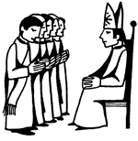
The Sacramental Rite of Ordination

Book of Common Prayer, pp. 510--555

"Ordination is the rite in which God gives authority and the grace of the Holy Spirit to those being made bishops, priests, and deacons, through prayer and the laying on of hands by bishops" (BCP, pp. 860-861).

"The gifts he gave were that some would be apostles, some prophets, some evangelists, some pastors and teachers, to equip the saints for the work of ministry, for the building up of the body of Christ, until all of us come to the unity of the faith and of the knowledge of the Son of God, to maturity, to the measure of the full stature of Christ" (Ephesians 4:11-13).

From the very beginning the Church has had people who were set apart for special service. Among his many disciples ("followers"), Jesus chose twelve apostles ("sent ones") to represent the twelve tribes of Israel or the fullness of God's covenant people (Luke 6:12-16). The twelve apostles subsequently set apart deacons to help them with their work and did so by the laying on of hands (Acts 6:1-7). While the number and function of ordained offices in the Church was varied and fluid (see 1 Corinthians 12:4-7, 27-31), eventually this structure solidified into the threefold ministry of bishops, priests (or presbyters), and deacons. One can see the beginnings of this in I Timothy and Titus. In the Episcopal Church we recognize this threefold historic order of ministry to be not a human creation but "a gift from God for the nurture of his people and the proclamation of his Gospel everywhere" (BCP, 510).

The Rite of Ordination does not make one a "professional Christian" or a `Christian of a higher order." As we have seen, through Baptism all Christians share in the priesthood of Christ and promise to "proclaim by word and example the Good News of God in Christ" (BCP, p.305). Bearing witness to the Gospel is not something that is entrusted only to the "professionals" but is a task taken on by all Christians by virtue of their baptism. "The Outline of Faith" makes this very clear when it states that the ministers of the Church are lay persons, bishops, priests, and deacons" (BCP, p. 855). The ministry of the baptized and the ministry of the ordained are not intended to conflict with each other or to be in tension. We are never to think of the ministry of the laity as somehow superfluous (clericalism) nor are we, under popular and democratic pressures, to think of the ministry of the ordained as unnecessary (anti-clericalism).

The Rite of Ordination springs from the Paschal Mystery of Christ, from the fact that through the Holy Spirit the Church shares in the priesthood of Christ. The crucified and risen Christ constitutes the Church as "a kingdom, priests serving his God and Father" (Revelation 1:6). The Church as a priestly body sets aside certain people who help the Church to realize and more fully live into her priesthood. Because this is the case, the ordained ministry exists for the sake of the Church and not the reverse.

It needs to be noted that the threefold order of ministry in the Episcopal Church is not intended to be a hierarchical order with bishops being at the top, priests being below bishops and deacons being below both. This order is functional not hierarchical meaning that each order of ordained ministry has duties proper to it within the context of the Body of Christ. The ministry of the Bishop is "to represent Christ and his Church, particularly as an apostle, chief priest, and pastor of a diocese; to guard the faith, unity, and discipline of the whole Church...and to ordain others to continue Christ's ministry" (BCP, p. 855). The bishop exercises an apostolic ministry as a successor to the apostles and as such the episcopal office is uniquely an office of unity in Christ and continuity with the apostolic faith. The Bishop represents the catholic Church to the Diocese and the Diocese to the catholic Church. The ministry of the Priest is "to represent Christ and his Church, particularly as pastor to the people; to share with the bishop in the overseeing of the Church, to proclaim the Gospel; to administer the sacraments; and to bless and declare pardon in the name of God" (BCP, p. 856). The ministry of a priest is to share in the bishop's ministry in the diocese in a particular place. Priests are not independent agents nor are they merely the bishop's subordinates. Rather, priests share in the bishop's ministry by extending that ministry to the local parish. The ministry of Deacons is "to represent Christ and his Church, particularly as a servant of those in need; and to assist bishops and priests in the proclamation of the Gospel and the administration of the sacraments" (BCP, p. 856). Deacons share in the ministry of the bishop and priests. They do this in three characteristic ways. Deacons have a special role in working with the poor and the ill, they also share in preaching the Gospel, and they assist in the celebration of the sacraments. Deacons normal do not preside at the celebration of the sacraments because that is not their role; the ministry is primarily one of service.

Each order of ministry serves the body of Christ in a distinct way in communion with the other orders. This makes clear a fundamental part of our understanding of the Church. The Church is not a bureaucratic religious organization whose structure can be expressed in a flow chart showing levels, of authority. The Church, rather, is a communion of people gathered around Jesus Christ the Son by the power of the Holy Spirit to glorify God the Father. All three orders of share in the work of God and all three together embody the gift of service that God has given to his people.

As with all the sacraments and sacramental rites, Ordination is ultimately an act of God. The Church, in the person of the bishop, prays that God will set apart a person for a particular office through Jesus Christ in the power of the Holy Spirit. This can be seen, for example, in the case of the ordination of a priest: "Therefore, Father, through Jesus Christ your Son, give your Holy Spirit to [the ordinand]; fill him with grace and power, and make him a priest in your Church" (BCP, p. 533).

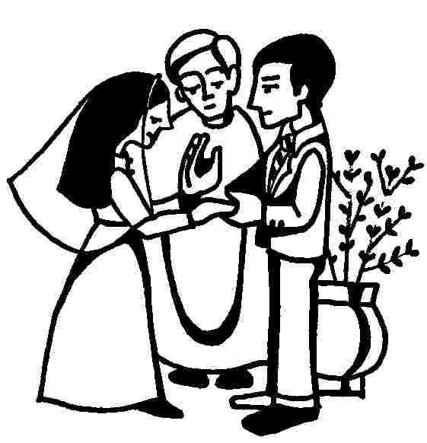
The Sacramental Rite of Marriage

Book of Common Prayer, pp. 422-438

"Christian marriage is a solemn and public covenant between a man and a woman in the presence of God. In the Episcopal Church it is required that one, at least of the parties must be a baptized Christian" (BCP, p. 422)

"Holy Matrimony is Christian marriage, in which the woman and man enter into a life-long union, make their vows before God and the Church, and receive the grace and blessing of God to help them fulfill their vows" (BCP, p. 861)

“So the LORD God caused a deep sleep to fall upon the man, and he slept; then he took one of his ribs and closed up its place with flesh. And the rib that the LORD God had taken from the man he made into a woman and brought her to the man. Then the man said, ‘This at last is bone of my bones and flesh of my flesh; this one shall be called Woman, for out of Man this one was taken.’ Therefore a man leaves his father and his mother and clings to his wife, and they become one flesh.”(Genesis 2:21-24)

Along with ordination, marriage is a vocational sacrament, that is, it is in response to a calling or vocation from God. Both the rite of holy orders and the sacrament of matrimony communicate a grace which helps Christians fulfill a vocation which becomes a means of living out their baptism. It is not to be expected that every Christian will be ordained and, likewise, it is not expected that every Christian will be married. Just as both clergy and laity have equal and valid vocations in the Church, so do the married and the single.

In order to understand the Christian theology of marriage one must understand some basic points:

(1) "The bond and covenant of marriage was established by God in creation" (BCP, p. 423).

While we are familiar with marriage as a social institution and as a rite of passage, the Church insists that marriage is a creation of God (Genesis 2) and, therefore, can not be altered or adapted to suit human conventions. For this reason, the Church has held that both same-sex unions and understandings of marriage which see the wife as the husband's inferior or his property have no place in the Church.

(2) "It [marriage] signifies to us the mystery of the union between Christ and his Church, and Holy Scripture commends it to be honored among all people" (BCP, p. 423). The sacramental nature of marriage consists, in part, in the fact that the relationship between husband and wife is a sign of the relationship between Christ and the Church. This principle is deeply rooted in biblical theology. Thus, Paul can write to husbands "love your wives just as Christ loved the church and gave himself up for her, in order to make her holy by cleansing her with the washing of water by the word" (Ephesians 5:25-26). Christ's sacrificial offering of himself on behalf of the Church is seen as a means of understanding the self-sacrificial relationship between husband and wife. In this way, we see what makes a Christian marriage Christian. In a Christian marriage, husband and wife not only make their vows before God and the Church and ask that God grant them the grace to fulfill their vows. But also, they offer their marriage to God to be used in God’s service to the furthering of God’s mission. A Christian marriage participates in God’s mission through the witness of the couples’ faithfulness and submission to one another.

(3) "The union of husband and wife in heart, body, and mind is intended by God for their mutual joy; for help and comfort given one another in prosperity and adversity; and, when it is God's will, for the procreation of children and for their nurture in the knowledge and love of the Lord" (BCP, p. 423). A Christian marriage is not a relationship of convenience or a contractual agreement but a "union" made possible by the grace of Jesus Christ. The joining together of husband and wife finds its expression in sexual intercourse and the openness to children as the fruit of intercourse. Sexual intercourse is a sign of the marriage covenant and has no place or meaning outside this covenant. The covenant of marriage shows to us God's intentions for human sexuality—God intends for sexual intercourse to be a means for building the union between husband and wife.

The BCP makes it clear that the promises exchanged in the marriage are both unconditional and life long, with both partners promising to be faithful to the other "so long as you both shall live" (BCP, p. 424) "from this day forward, for better for worse, for richer for poorer, in sickness and in health, to love and to cherish, until we are parted by death" (BCP, p. 427).

Sacramentally speaking, this rite is celebrated by the husband and wife; marriage is not a sacrament celebrated by a priest. The priest does, however, bless the marriage on behalf on the Church (BCP, pp. 430-431).

